Below is a system diagram map of Intermountain’s PLEXOS modeling. PLEXOS’ system diagram does not have an option to display transportation pipeline names. Page 2 and 3 include more information on the transportation names. You will notice that some names don’t appear, specifically the non-core, and that is because PLEXOS posts the locations with the same Geocode on top of each other. For example, Sun Valley NC is in the same spot as the Sun Valley node. Intermountain plans to work with Energy Exemplar to make the system diagram map more viewer friendly.  
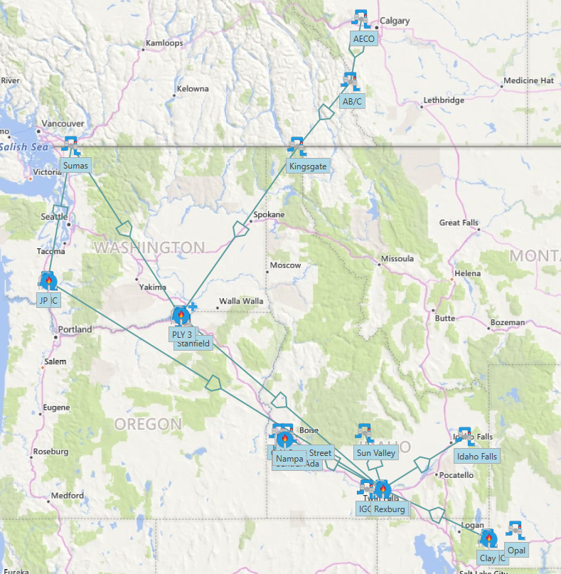

Below is a snip of PLEXOS software that shows how the model is set up. For example, the first contract is a contract that flows from Stanfield to Intermountain’s system.

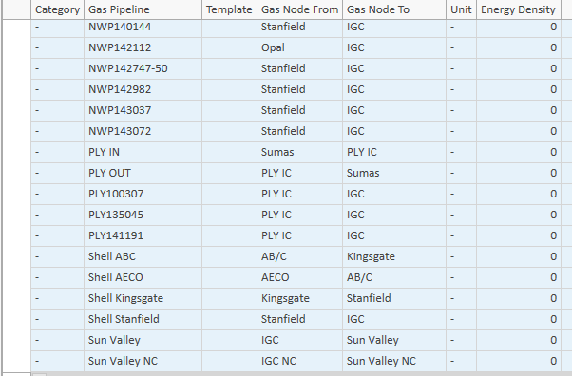

On the following page, Intermountain has provided the full list of transportation contracts along with the node they come from and where they go. These nodes can be tied to the system map from above.

